A Smokefree Future consultation – PR and social media guide
1/ Background
Smoking is the biggest cause of cancer, driver of health inequalities and premature death in the UK.
Health partners nationally and regionally have welcomed a UK-wide Government consultation to stop the start of new smokers as a vital step to create a smokefree generation (October 2023).
2/ Aims
The voices of partners in Greater Manchester was pivotal in achieving the smokefree law of 2007 and are vital once again:
1/ To create a groundswell of support from health and local authority partners across the Greater Manchester around a smokefree generation
2/ To give decision makers nationally the confidence that a smokefree future is not only needed but workable and wanted…
We are now urging partners to respond, to make your own public-facing declaration to support a smokefree future and ensure once again our region and our localities can have a say.
3/ What partners can do
Raising the age of sale for tobacco is the biggest single measure in the proposals set out by the government, which also include proposals to ensure vaping products are aimed at adults and are not promoted at children.
The consultation runs until Dec 6 and Fresh and ASH is supporting local authorities and NHS partners to:
- Pass a motion for your local authority to declare its support and add to the many voices across the country calling for a smokefree generation
- Submit a consultation response before the consultation close on December 6
- Share your organisation’s commitment to a smokefree future publicly with the help of this toolkit and other resources
- Make a short video, use our template press release and our social copy and images – and retweet our content from @FreshSmokeFree
4/ Key timings and aims
Raising the age of sale 1 year every year for those 14 and some aspects of vaping regulations will require primary legislation.
The period between now and December 6 is a key time for local responses, however the legislative process around a smokefree generation will be longer (and hinge partly on timings for any General Election).
The consultation process only the first part of the journey towards legislation. Securing a strong response is important but there will still be a long way to go following close of the consultation to secure legislation and health partners will continue to make the case throughout this period.
DATE | DETAIL | ACTIVITY
Oct 12 | Consultation launch | Fresh/ ASH welcomed proposals
Nov 7 | Kings Speech | -Legislation could be announced  -Social / PR media activity to welcome any announcement  -Fresh PR and social media activity including videos of young people and young smokers….
Dec 6 | Consultation closes | Partners to have submitted response  Government generally takes around 12 weeks to respond to a consultation
Feb-July ‘24 | Bill potentially makes its way through Commons or Lords | Any Bill containing legislation must be tabled and will go through five stages in the House of Commons and the House of Lords

5/ Key facts at a glance
Tobacco is the only known product which kills up to 2 in 3 users. It costs Greater Manchester £2.7Bn a year in costs to the NHS, social care and the economy.
Most smokers start before 18, end up regretting ever getting hooked, and would like to stop. Most of all they don’t want their own children or grandchildren to get hooked on a product now known to kill up to 2 in 3 long term users.
Action is not only needed to create a “Smokefree Generation” but is also popular with the public. In 2023 79% of Greater Manchester adults support ending smoking with a target of fewer than 5% smoking.
6/ Key messages
- Tobacco is the biggest cause of cancer, ill health and early death and fuels health inequalities
- Tobacco hooks most users as children and kills up 2 to 2 in 3 long term smokers. No other product on our shops does this.
- Tobacco costs Greater Manchester £2.7 billion a year in medical, health and social care, lost earnings and smoking-related unemployment.
- There is high public support and cross party support for a smokefree future for future generations. It is time to give our next generation a better life with decisive and bold action across the UK.
- Most smokers regret ever starting and don’t want their own children and grandchildren to start
- If you smoke, switch to vaping instead. If you don’t smoke, don’t vape. We need to ensure we address the price, marketing and packaging of these products to reduce their appeal to children.

7/ Draft web/ press release copy
Greater Manchester is supporting proposals across the UK to reduce the death and disease from smoking.
Tobacco is the biggest cause of cancer, ill health and early death in Greater Manchester, fuelling health inequalities and killing 2 in 3 smokers early.
Greater Manchester has responded to the UK-wide Government consultation aimed at protecting future generations from the harms of smoking and reducing youth vaping.
We are committed to doing all we can to reduce smoking prevalence in Greater Manchester to 5% by 2030 and 79% of Greater Manchester adults support this. As estimated by ASH in their ready reckoner tool based on 2022 data, smoking rates in Greater Manchester cost £2.7Bn each year in healthcare costs (£104.5M), lost productivity (£1.7Bn), social care costs (£863.3M) and fire costs (£20.1M).
INSERT SPOKESPERSON said: “We support all efforts now to reach the aim of reducing smoking and are proud to respond now to this consultation.
“It is clear that action on smoking is not only needed, but it is wanted too.
“We now have a chance to make a once-in-a-generation difference to young people and enable them to have a life without the addiction, the cost and the diseases caused by tobacco.”
8/ Social Posts
It is time to support more adults to quit smoking and give our children the chance of a life tobacco free – that is why we support proposals across the UK for a #SmokefreeGeneration | 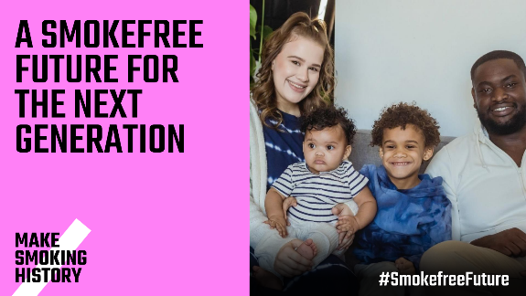
Smoking is the biggest cause of cancer, ill health and premature death in INSERT AREA. That is why INSERT ORGANISATION has declared its support for proposals for a smokefree generation for the UK #SmokefreeFuture | VIDEO: Matt Evison – Making Smoking History for Greater Manchester
Tobacco is the biggest cause of cancer, ill health and early death and fuels health inequalities. Let’s end this misery. We are supporting partners across the UK in supporting a #SmokefreeFuture | VIDEO: Andrea Crossfield (Consultation)  OR  VIDEO: Dr David Crane (Smoke Free App) on Making Smoking History
Tobacco is the only known product which kills up to 2 in 3 users. As well as lives lost it costs the North East £992 million a year to the NHS, social care and the economy. We support proposals across the UK for a #SmokefreeFuture | 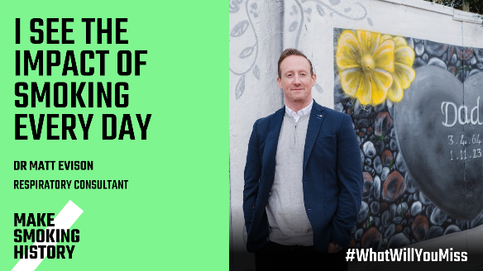
Most smokers start as children and end up hooked on a lifelong addiction which costs tens of thousands of pounds and ends up killing 2 in 3. We support proposals across the UK for a #SmokefreeFuture. | 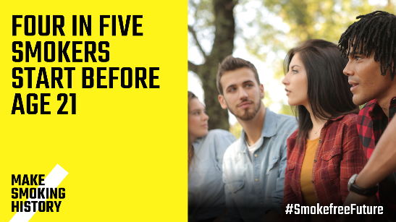
We now have a chance to make a once-in-a-generation difference to young people and enable them to have a life without the addiction, the cost and the diseases caused by tobacco #SmokefreeFuture | VIDEO: Andrea Crossfield (Consultation)
Nobody wants our children to become the next generation of adults with smoking-caused diseases on our hospital wards. We support proposals for a #SmokefreeFuture across the UK. | VIDEO: Matt Evison – Making Smoking History for Individuals
We have a chance to make a better life for a generation of young people growing up today. That is why we support a #SmokefreeFuture | 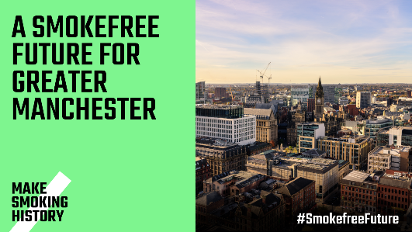

Appendix 1 – local costs of smoking.

Area Name | Number of smokers | Overall cost | Healthcare costs | Productivity loss | Social care costs | Fire costs
North West | 784,400 | £6.8Bn | £259.4M | £4.3Bn | £2.2Bn | £49.9M
Greater Manchester ICB | 317,000 | £2.7Bn | £104.5M | £1.7Bn | £863.3M | £20.1M
Bolton | 31,900 | £264.4M | £10.3M | £174.6M | £77.7M | £2.4M
Bury | 17,600 | £165.8M | £6.1M | £104.9M | £53.8M | £1.0M
Manchester | 73,400 | £628.8M | £22.4M | £394.2M | £208.1M | £4.2M
Oldham | 19,700 | £191.2M | £6.5M | £112.2M | £70.4M | £2.1M
Rochdale | 25,900 | £241.9M | £9.5M | £153.3M | £77.4M | £1.6M
Salford | 32,000 | £266.0M | £10.9M | £168.0M | £85.3M | £1.7M
Stockport | 27,500 | £232.3M | £8.6M | £154.0M | £68.1M | £1.7M
Tameside | 36,400 | £315.3M | £12.3M | £219.8M | £81.2M | £2.0M
Trafford | 14,400 | £138.6M | £4.8M | £83.1M | £49.6M | £1.2M
Wigan | 38,500 | £292.6M | £13.3M | £182.5M | £94.6M | £2.1M

