Suggested copy for GM partner’s social medial channels
For images use the 1:1 files for Facebook and Instagram and the 16:9 files for Twitter.

Artwork | Copy
Link to: TV ad | Smoking is the biggest cause of preventable death and ill-health in Greater Manchester.  It has an impact on everyone’s lives and takes far too many of our loved ones from us – missing out on so many special memories. That’s our message as we launch our new campaign.  #makesmokinghistory #whatwillyoumiss #quitsmoking #stopsmoking
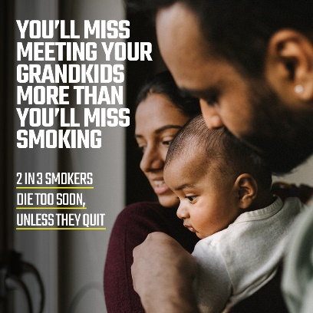  7 x different versions of the ad to choose from | 2 in 3 smokers will die too soon unless they quit. Don't miss the moments that matter most – quit smoking today.  @thesmokefreeapp gives you 24/7 access to trained stop smoking advisors and helps you monitor your health improvements as well as money saved. Get it free for 6 months if you live in Greater Manchester (T&Cs apply)  Visit www.smokefreeapp.com/GM  #makesmokinghistory #whatwillyoumiss #quitsmoking #stopsmoking
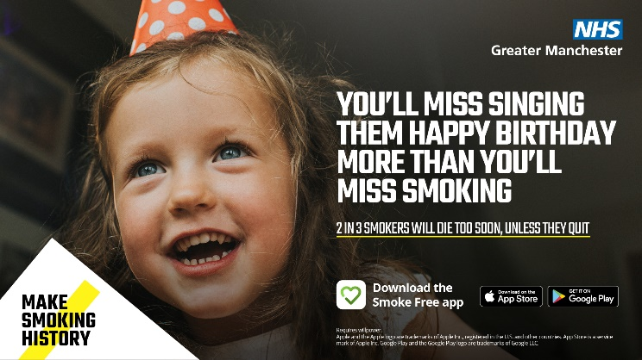  5 x different versions of the above ad to choose from | Stopping smoking is one of the best things you can do for you and your loved ones. Don’t miss the moments that matter most – quit today.  @thesmokefreeapp gives you 24/7 access to trained stop smoking advisors and helps you monitor your health improvements as well as money saved. Get it free for 6 months if you live in Greater Manchester (T&Cs apply)  Visit www.smokefreeapp.com/GM  #makesmokinghistory #whatwillyoumiss #quitsmoking #stopsmoking
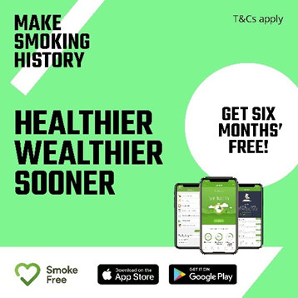 | Did you know stopping smoking can save you around £2,000 a year?  Try @thesmokefreeapp today and get it free for 6 months if you live in Greater Manchester (T&Cs apply)  You’ll have 24/7 access to trained stop smoking advisors and helps you monitor your health improvements as well as money saved.  #makesmokinghistory #whatwillyoumiss #quitsmoking #stopsmoking
Video link included in copy | Smoking is the biggest cause of preventable death and ill-health in Greater Manchester.  It has an impact on everyone’s lives and takes far too many of our loved ones from us – missing out on so many special memories. See reactions from Greater Manchester residents to Making Smoking History’s latest ‘What Will You Miss’ campaign here.  #makesmokinghistory #whatwillyoumiss #quitsmoking #stopsmoking
Video link included in copy | Following new @DHSCgovuk plans for a smokefree generation, we asked Greater Manchester residents: How do you feel about a smokefree future? Here’s what they had to say #SmokefreeFuture #Smokefreegeneration  Link to video
Video link included in copy | After smoking for many years, being diagnosed with COPD, and tragically losing friends to smoking – Debbie from Oldham, describes how smoking has impacted her life and how she finally managed to quit smoking for good. Hear Debbie’s story here Debbie's story - YouTube  #makesmokinghistory #whatwillyoumiss #quitsmoking #stopsmoking

